**ÇANKAYA UNIVERSITY**

**COMPUTER ENGINEERING DEPARTMENT**

**CENG 361 Innovative Game Design Assignment-1**

**Subject : 2D Single Player Tank Game**

**Instructor : Dr. Ali Seydi Keçeli**

**Assignment Deadline : 28.04.2021**

**Aim**

In this experiment you are expected to develop a simple tank game like “NES Battle City”. You can inspect NES Battle City from link below:

<https://www.youtube.com/watch?v=MPsA5PtfdL0>

**Unlike Battle City your game will be a side scroll game with a level of at least 4 or 5 screen size.**

**There should be a boss battle at the end of the level. You can use a larger tank sprite as boss.**

You are not expected to implement a replica of the Battle City. It will be sufficient to implement mechanics and rules described below:

1. Player will translate and rotate tank via arrow keys.
2. Enemy tanks will move horizontally and vertically and fire randomly. You can define a rule or put some AI for enemy tanks
3. You should define rectangular terrain objects. There should be at least two type of terrain object one can be destructible with tank bullet other type cannot be. You can add texture to terrain objects or you can use solid colours.
4. Tanks cannot pass through terrain objects.
5. You can use Natural Pixel Art Assets for terrain objects
6. You can use 2D Si Fi Weapon Pack Rocket asset as tank bullet.
7. The goal of game is to kill all enemy tanks.
8. Player has at least one life and game will be over when all lives are lost.
9. When an enemy tank is shot it should be removed from the game. Explosion effect is optional.
10. There should be a follow camera.
11. Sounds can be added and will be rewarded.
12. You can use tank sprites delivered with the 3rd week course materials.

Sample screen shot of the game are shown below:

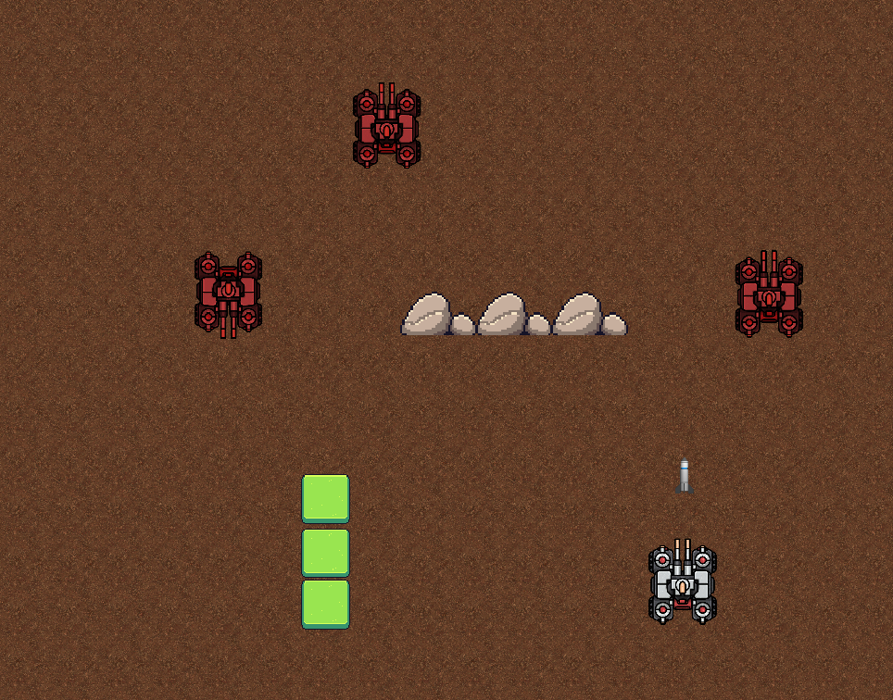

Figure-1 A sample screen shot from the game

**Notes:**

1. **You can ask any question via web online, please do not ask via e-mail.**
2. **Submission Format**

**StudentId.rar**

**|- Unity Package or (project folder)**

**|- Game Play Video**